MAR BASELIOS INSTITUTE OF TECHNOLOGY AND SCIENCE

NELLIMATTOM P.O, KOTHAMANGALAM, KERALA


APJ ABDUL KALAM TECHNOLOGICAL UNIVERSITY THIRUVANANTHAPURAM

PBCST304 - OBJECT ORIENTED PROGRAMMING - PROJECT REPORT

AGRI-SMART: AI CROP HEALTH DIAGNOSIS & GLOBAL MARKET INTELLIGENCE SYSTEM

Submitted by
Abin Tenson (MBI25CS013)
Akshai Pradeep (MBI25CS024)
Arjun TA (MBI25CS054)
Aayush Sunil Kambrath (MBI25CS001)

In partial fulfilment for the award of the degree of
BACHELOR OF TECHNOLOGY
in
COMPUTER SCIENCE AND ENGINEERING

SEPTEMBER 2026

MAR BASELIOS INSTITUTE OF TECHNOLOGY AND SCIENCE

NELLIMATTOM P.O, KOTHAMANGALAM, KERALA
DEPARTMENT OF COMPUTER SCIENCE AND ENGINEERING

BONAFIDE CERTIFICATE

This is to certify that the report on Aagri Smart is a bonafide record of PBCST304 - OBJECT ORIENTED PROGRAMMING PROJECT presented by Abin Tenson (MBI25CS013), Akshai
Predeep (MBI25CS024), Arjun TA(MBI25CS054) and Aayush Sunil Kambrath
(MBI25CS001) in partial fulfillment of requirements for the award of the degree of Bachelor of Technology in Computer Science and Engineering of APJ Abdul Kalam Technological University, Thiruvananthapuram during the academic year 2026- 2027.
Project Coordinator |  | Head of the Department
Ms. Reenu Renjith |  | Dr.Anju Raveendran
Assistant Professor |  | Associate Professor
Department of CSE |  | Department of CSE

ACKNOWLEDGEMENT

First and foremost, we thank ALMIGHTY GOD who gave me the inner strength, resource and ability to complete our work successfully, without which all our efforts would have been in vain.
We sincerely thank Dr. Thomas George, our principal, for providing the facilities and support that enabled the successful completion of this phase of the project
We express our deep sense of gratitude to Prof. Bonia Jose, Head, Department of Computer Science and Engineering for his insightful comments, encouragements and critical inquiries, which inspired me to widen our project from various perspectives. We would like to extend our gratitude to Prof. Reenu Renjith for the creative suggestions, valuable advices, mental support and guidance as our project coordinators.
We use this opportunity to thank all faculty in the department of Computer Science and Engineering for supporting me to complete this phase of the project.
Finally, we would like to acknowledge the heartfelt efforts, comments, criticisms, co-operation extended to me by our beloved classmates during the preparation and presentation of this work.

Abin Tenson (MBI25CS013)
Akshai Pradeep (MBI25CS024)
Arjun TA (MBI25CS054)
Aayush Sunil Kambrath (MBI25CS001)

ABSTRACT

Agriculture serves as the economic backbone of developing regions, yet farmers routinely encounter substantial financial losses driven by unmitigated crop pathologies, localized market informational asymmetry, and limited visibility into lucrative international trade routes. To overcome these constraints, this project presents Agri-Smart, a modular, terminal-based software management system developed entirely in Java using Object-Oriented Programming (OOP) paradigms and persistent local file storage. The system employs in-memory collections (List, Map, Set) for zero-overhead runtime retrieval and serializes user accounts, customized crop mappings, and catalog configurations directly to flat files via Java File I/O (BufferedReader and BufferedWriter), completely eliminating dependencies on external SQL database servers.
At its functional core, Agri-Smart features a menu-driven Crop Health Diagnostic Module indexing over 15 staple, commercial, and plantation crops, enabling rapid physical symptom matching, yield risk assessment, and certified biological or chemical treatment delivery, supported by a live HTTP botanical API fallback for unlisted anomalies. Concurrently, a non-blocking background thread powered by ScheduledExecutorService auto-synchronizes domestic mandi spot prices and demand shifts every 5 minutes, while an International Export Portal maps local produce against foreign commercial terminals to calculate live dollar benchmarks and projected profit margins. Protected by role-based authentication separating personalized farmer profiles from administrative management controls, Agri-Smart provides an extensible, portable, and zero-dependency technological solution connecting plant pathology identification with commercial trade profitability.
TABLE OF CONTENTS
ACKNOWLEDGEMENT i
ABSTRACT ii
LIST OF FIGURES iii
LIST OF ABBREVIATIONS iv
1. INTRODUCTION 1
1.1 BACKGROUND AND MOTIVATION 1
1.2 OBJECTIVES OF THE PROPOSED SYSTEM 3
2. SYSTEM REQUIREMENTS 4
2.1 SOFTWARE REQUIREMENTS 4
3. SYSTEM ANALYSIS 5
3.1 PROPOSED SYSTEM 5
3.2 SYSTEM ARCHITECTURE 7
3.3 MODULES 11
3.3.1 User Authentication Module 11
3.3.2 Persistent File Storage Module 11
3.3.3 Farmer Crop Profiling Module 12
3.3.4 Crop Health Diagnostic Module 12
3.3.5 Domestic Market Intelligence Module 12
3.3.6 Global Export Intelligence Module 13
3.3.7 Administrator Management Module 13
4. IMPLEMENTATION
4.1 Source code 14
4.2 Sample output 34

5. CONCLUSION AND FUTURE WORK 38
5.1 Conclusion 38
5.2 Future Work 38

REFERENCES 40

LIST OF FIGURES

Fig No. | Title | Page No.
4.1 | Architecture Diagram | 7
4.2 | Class Diagram | 8
5.1 | User Login Portal | 34
5.2 | Farmer Crop Selection Menu | 34
5.3 | Farmer Dashboard | 35
5.4 | Crop Health Diagnostic Module | 35
5.5 | local Market Prices with online auto updater | 36
5.6 | International Export Prices with Online Updater | 36
5.7  5.8 | Admin Control Pannel  Online Api Advisory | 37  37

LIST OF ABBREVIATIONS

- API — Application Programming Interface
- CLI — Command Line Interface
- CSE — Computer Science and Engineering
- e-NAM — Electronic National Agriculture Market
- HTTP — Hypertext Transfer Protocol
- I/O — Input / Output
- IDE — Integrated Development Environment
- JDK — Java Development Kit
- MBITS — Mar Baselios Institute of Technology and Science
- OOP — Object-Oriented Programming
- OS — Operating System
- RAM — Random Access Memory
- SMS — Short Message Service
- UI — User Interface
- URL — Uniform Resource Locator

CHAPTER - 1

INTRODUCTION

BACKGROUND AND MOTIVATION
Agriculture represents the primary livelihood for significant portions of the developing world; however, traditional agricultural management continues to encounter severe structural and technological inefficiencies. Cultivators are routinely exposed to catastrophic crop yield depreciation triggered by insect attacks, fungal outbreaks, viral lesions, and nutritional deficits that remain unchecked due to delayed diagnostic intervention. In conventional rural setups, obtaining an accurate pathology diagnosis requires manual inspections from government agricultural extension officers or travel to remote agronomy clinics. This delay allows pathogens to spread across vast crop acreage, undermining the farmer's seasonal investment.
In parallel to agronomic hazards, farmers face intense economic asymmetry within domestic agricultural marketing. Primary producers rarely have real-time visibility into the dynamic supply-demand swings of regional mandis and wholesale terminal markets. Localized transactions frequently depend on intermediaries and middlemen who dictate arbitrary pricing, suppressing farm-gate profit margins. Furthermore, while globalization and international shipping lines offer lucrative price premiums for spices, cereals, and cash crops in foreign commercial terminals (such as the UAE, Europe, and the USA), smallholder and commercial producers lack accessible software utilities that present export price parity, regulatory compliance thresholds, and estimated profit metrics.
Developing an accessible, resource-efficient computational system to mitigate both pathological risks and trade opacity is essential. Java, as an Object-Oriented programming platform, offers exceptional modularity, cross-platform portability, multi-threaded task management, and built-in networking capabilities. By leveraging Java Collections for in-memory operations and standard File I/O streams for cross-session data persistence, an agricultural support system can be engineered to run reliably in terminal environments on entry-level computers without needing complex web frameworks or dedicated SQL server setups. Agri-Smart was conceived to unify rapid disease symptom diagnosis, automated fallback mechanisms, live domestic price updates, and global export intelligence into an accessible terminal tool.

OBJECTIVES OF THE PROPOSED SYSTEM
The objectives of the proposed system are:

- To design an interactive, menu-driven crop pathology diagnostic system spanning 15+ staple, tuber, cereal, and plantation crops with deterministic symptom matching, yield loss risk estimations, and certified remedial prescriptions.

- To implement an automated online botanical API fallback using Java’s native java.net.http.HttpClient to query external digital endpoints when unindexed anomalies are encountered.

- To construct a non-blocking background concurrency pipeline via ScheduledExecutorService that periodically updates mandi wholesale commodity prices without freezing terminal input.

- To establish an international cross-border trade portal displaying global port prices, currency benchmarks, and calculated profit margins.

- To maintain user authentication and profile customization through an in-memory repository backed by local Java File I/O persistence (BufferedReader and BufferedWriter).

- To supply administrators with privileged capabilities to append newly discovered diseases, add new crop varieties, and inspect user directories.
CHAPTER - 2

SYSTEM REQUIREMENTS

SOFTWARE REQUIREMENTS
- Operating System: Windows 10 / Windows 11 (64-bit), Linux, or macOS
- Development Environment: Java Development Kit (JDK 17 or higher)
- Primary IDE: Visual Studio Code with Java Extension Pack / IntelliJ IDEA
- Terminal Shell: Windows PowerShell, Command Prompt, or Unix Bash shell
- Data Storage / Persistence: In-memory Collections (ArrayList, HashMap, HashSet) paired with standard Java File I/O (java.io.File, BufferedReader, BufferedWriter)

CHAPTER - 3

PROPOSED SYSTEM

PROPOSED SYSTEM
The proposed system, Agri-Smart: Crop Health & Market Intelligence System, is an advanced terminal-based software platform engineered to provide reliable agricultural decision-support and commercial trade intelligence to cultivators and administrators. Conventional agricultural workflows rely heavily on manual field observation and fragmented intermediaries, leaving farmers vulnerable to severe yield losses from unchecked pathologies and suppressed profits from rural market information asymmetry. Agri-Smart addresses these challenges by consolidating deterministic crop disease diagnosis, live botanical web API lookups, concurrent domestic mandi price tracking, and cross-border international export analytics into a cohesive, portable console application. Built entirely in pure Java using Object-Oriented Programming (OOP) paradigms, the system utilizes in-memory collections (List, Map, Set) for zero-overhead runtime transactions and standard Java File I/O streams (BufferedReader, BufferedWriter) for cross-session flat-file persistence, eliminating external SQL database dependencies.
The platform features an intuitive, menu-driven command-line interface protected by role-based authentication separating farmer accounts from administrative controls. Upon logging in, farmers configure an active crop cultivation profile that personalizes the rest of the application. The primary Crop Health Diagnostic Module indexes over 15 staple, spice, and plantation crops, allowing growers to match observed physical symptoms against an indexed pathology catalog to obtain confirmed disease identifications, yield loss risk percentages, and chemical or biological treatment measures. For rare or uncataloged symptoms, the system invokes an automated external fallback using java.net.http.HttpClient to retrieve botanical diagnostic summaries over the web.
To overcome economic exploitation, Agri-Smart incorporates automated domestic market synchronization and international trade analytics. Using Java’s ScheduledExecutorService, a background daemon thread updates regional mandi commodity rates every 5 minutes with transparent price trend indicators without interrupting active user navigation. In parallel, the Cross-Border Global Export Intelligence Portal benchmarks domestic commodity prices against major international terminals (such as Dubai, Rotterdam, and Singapore), calculating foreign exchange valuations and projected net profit margins. Supported by an administrative management module that enables dynamic catalog expansion, the proposed platform delivers an accessible, zero-dependency software architecture designed to bridge plant pathology identification with domestic and international trade profitability.

SYSTEM ARCHITECTURE
The architecture diagram for the proposed system is shown in Figure 4.1.
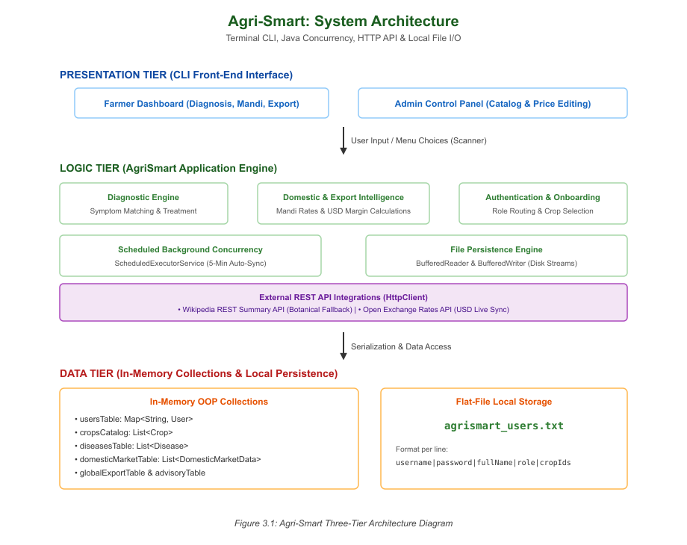
Figure 4.1 Architecture Diagram

The class diagram for the proposed system is shown in Figure 4.2.
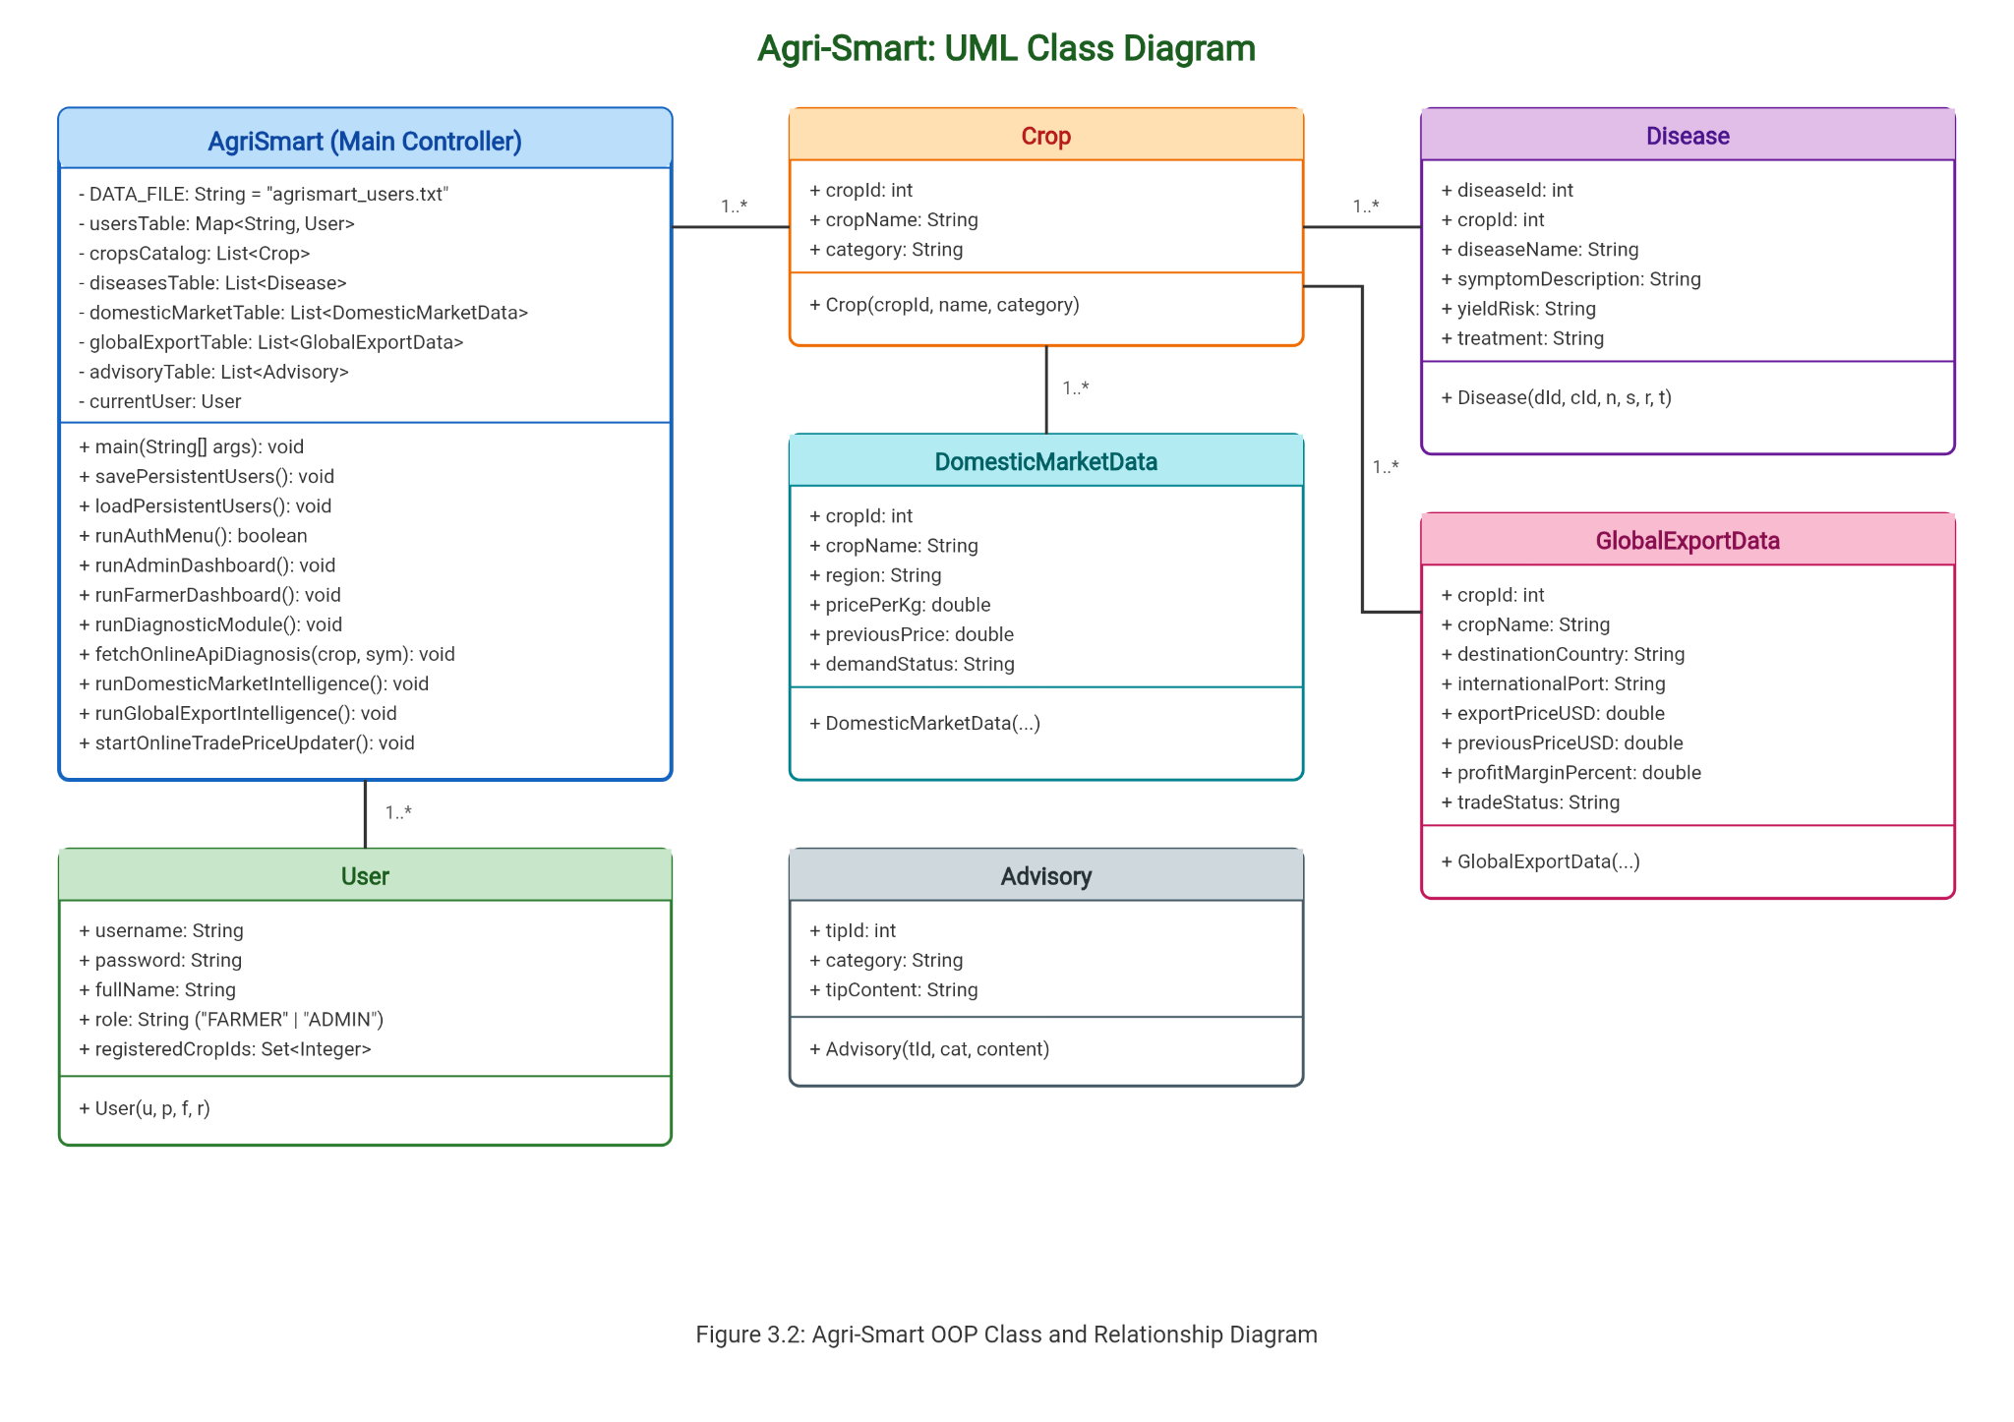

Figure 4.2 Class Diagram
The system execution begins with the initialization of the runtime catalogs and persistent state. Upon launch, the platform invokes initializeDatabase() to seed default master data—including over 15 staple, spice, tuber, and plantation crops, their corresponding disease pathologies, initial domestic mandi wholesale rates, and global export benchmarks. Concurrently, the File Persistence Engine executes loadPersistentUsers() to scan the local file directory for agrismart_users.txt. If found, the application deserializes stored user credentials and registered crop preferences into the in-memory usersTable collection using Java BufferedReader streams, restoring state across previous terminal sessions without requiring an external database connection.
Following data loading, the system invokes startOnlineTradePriceUpdater() to start an asynchronous background daemon thread managed by Java’s ScheduledExecutorService. This task runs automatically at fixed 5-minute intervals. At each execution cycle, it transmits a non-blocking GET request to an external currency exchange REST endpoint ([https://open.er-api.com/v6/latest/USD](https://open.er-api.com/v6/latest/USD)) via java.net.http.HttpClient to monitor live USD reference points. Simultaneously, it computes dynamic delta variances across domestic mandi spot rates and overseas export prices in domesticMarketTable and globalExportTable, tracking previous prices to compute market momentum and update supply-demand classifications (High, Medium, Low) in real time.
The interactive terminal interface is managed via runAuthMenu(), which prompts the user to either log in to an existing account, register a new farmer profile, or terminate the application. During authentication, user input is matched against usersTable. If credentials resolve successfully, session context is stored in currentUser and role-based access control (RBAC) directs execution to either runAdminDashboard() or runFarmerDashboard():
- Farmer Workflow: If a newly registered or authenticated farmer has not yet configured their cultivation preferences, the system triggers onboardFarmerCrops(), presenting an indexed checklist of all master crops. The farmer selects crop IDs matching their farm holdings, storing them in a HashSet<Integer> (registeredCropIds). This personalizes subsequent views. When diagnosing plant diseases via runDiagnosticModule(), the farmer selects from their registered crops, reviews cataloged physical symptom manifestations, and receives an instant pathology report detailing the identified pathogen, estimated yield loss risk, and chemical or biological remediation protocols. If the observed field symptom is unlisted or mutating, the user selects the fallback option, prompting fetchOnlineApiDiagnosis() to query the Wikipedia REST summary API ([https://en.wikipedia.org/api/rest_v1/page/summary/](https://en.wikipedia.org/api/rest_v1/page/summary/)) via HttpClient for live botanical advisory text. Farmers can also review dynamic domestic mandi rates via runDomesticMarketIntelligence(), evaluate overseas profit margins through runGlobalExportIntelligence(), access extension farming guidelines via runNoviceAdvisoryModule(), or update crop selections.
- Administrator Workflow: Users authenticated under the ADMIN role access elevated data curation capabilities via runAdminDashboard(). Administrators can dynamically register new crop types via adminAddNewCrop(), append newly identified diseases and treatment guidelines via adminAddNewDisease(), overwrite domestic mandi spot rates and demand levels via adminUpdateDomesticPrice(), adjust global export rates and profit margin percentages via adminUpdateExportRate(), and inspect a formatted directory of all registered users and their crop profiles via adminViewAllUsers().
When a user logs out or selects the application exit command, the platform invokes savePersistentUsers(), serializing the modified state back to agrismart_users.txt using a BufferedWriter stream. Finally, scheduler.shutdown() is called to terminate the background daemon thread pool cleanly and release all system resources.

MODULES
The modules of the prThe proposed system comprises the following primary modules:
- User Authentication Module
- Persistent File Storage Module
- Farmer Crop Profiling Module
- Crop Health Diagnostic Module
- Domestic Market Intelligence Module
- Global Export Intelligence Module
- Administrator Management Module

User Authentication Module
The User Authentication Module handles user registration, authentication, and role routing. It ensures that only authorized users can access the application and separates farmer privileges from administrative controls.
Main Functions:
- Register Farmer: Register new farmers by collecting their full name, unique username, and password.
- User Login: Authenticate credentials against stored records and establish the active user session.
- Role Assignment: Route access permissions based on role (FARMER or ADMIN).
    - Persistent File Storage Module
The Persistent File Storage Module manages data persistence without external database software. It serializes and deserializes user credentials and selected crop associations to and from a local flat file using Java File I/O streams.
Main Functions:
- Load Data: Read and parse agrismart_users.txt using BufferedReader on system startup.
- Save Data: Write pipe-delimited user records (username|password|fullName|role|crops) to disk using BufferedWriter on profile updates or logout.
    - Farmer Crop Profiling Module

The Farmer Crop Profiling Module enables cultivators to customize their operational profile. It maps cultivated crop varieties to the logged-in farmer account, selectively filtering all subsequent diagnostic and market views.
Main Functions:
- Crop Selection: Display cataloged crops and record user-selected crop IDs.
- Profile Update: Modify and save active cultivated crops directly to user records.
    - Crop Health Diagnostic Module

The Crop Health Diagnostic Module identifies crop pathologies and recommends remedies. It matches observed field symptoms against cataloged plant diseases across 15+ crops and queries an external botanical API for unlisted anomalies.
Main Functions:
- Symptom Matching: Perform deterministic matching to display confirmed disease name, yield risk, and treatment.
- API Fallback: Query external botanical REST services via HttpClient when anomalous symptoms are reported.
    - Domestic Market Intelligence Module
The Domestic Market Intelligence Module provides real-time mandi spot prices across regional wholesale terminals. It monitors market price shifts and tracks supply-demand ratings for registered crops.

Main Functions:
- View Mandi Rates: Display wholesale prices (₹/kg), historical variance indicators, and demand levels.
- Background Auto-Sync: Execute periodic rate updates every 5 minutes using ScheduledExecutorService.
    - Global Export Intelligence Module
The Global Export Intelligence Module tracks international agricultural commodity benchmarks. It directs growers toward high-valuation foreign shipping hubs to improve profitability over domestic trade
Main Functions:
- Trade Evaluation: Correlate domestic crops with foreign ports (e.g., Dubai, Rotterdam, Los Angeles).
- Margin Calculation: Compute overseas price valuations in USD and calculate projected net profit margins.
    - Administrator Management Module
The Administrator Management Module gives system administrators total control over core databases and user catalogs.
Main Functions:
- Add Crop: Register new crop types and initial baseline market rates into the master catalog.
- Catalog Disease: Add new plant pathologies, symptom descriptions, yield risk percentages, and treatments.
- Price Update: Manually revise domestic mandi prices, export benchmarks, and demand ratings.
- View Users: Display a directory of all registered users, roles, and assigned crop profiles.

CHAPTER - 4

IMPLEMENTATION
5.1 SOURCE CODE
- AgriSmart.java

import java.io.*;
import java.net.URI;
import java.net.URLEncoder;
import java.net.http.HttpClient;
import java.net.http.HttpRequest;
import java.net.http.HttpResponse;
import java.nio.charset.StandardCharsets;
import java.time.Duration;
import java.util.*;
import java.util.concurrent.*;

public class AgriSmart {

private static final String DATA_FILE = "agrismart_users.txt";
private static final Scanner scanner = new Scanner(System.in);
private static final ScheduledExecutorService scheduler = Executors.newScheduledThreadPool(1);
private static final HttpClient httpClient = HttpClient.newBuilder()
.connectTimeout(Duration.ofSeconds(5))
.build();

// Datastores
private static final Map<String, User> usersTable = new HashMap<>();
private static final List<Crop> cropsCatalog = new ArrayList<>();
private static final List<Disease> diseasesTable = new ArrayList<>();
private static final List<DomesticMarketData> domesticMarketTable = new ArrayList<>();
private static final List<GlobalExportData> globalExportTable = new ArrayList<>();
private static final List<Advisory> advisoryTable = new ArrayList<>();

// Current Session
private static User currentUser = null;

public static void main(String[] args) {
initializeDatabase();
loadPersistentUsers(); // Reads saved user profiles from file
startOnlineTradePriceUpdater();

boolean systemRunning = true;
while (systemRunning) {
if (currentUser == null) {
systemRunning = runAuthMenu();
} else if (currentUser.role.equals("ADMIN")) {
runAdminDashboard();
} else {
runFarmerDashboard();
}
}

savePersistentUsers(); // Persists state before termination
scheduler.shutdown();
System.out.println("\nAgri-Smart System Terminated. Goodbye!");
}

// ==========================================================
// PERSISTENT FILE STORAGE ENGINE
// ==========================================================
private static void savePersistentUsers() {
try (BufferedWriter writer = new BufferedWriter(new FileWriter(DATA_FILE))) {
for (User u : usersTable.values()) {
StringBuilder crops = new StringBuilder();
for (int id : u.registeredCropIds) {
crops.append(id).append(",");
}
String cropsData = crops.length() > 0 ? crops.substring(0, crops.length() - 1) : "none";
// Format: username|password|fullName|role|crops
writer.write(u.username + "|" + u.password + "|" + u.fullName + "|" + u.role + "|" + cropsData);
writer.newLine();
}
} catch (IOException e) {
System.err.println("Notice: Could not save persistent data: " + e.getMessage());
}
}

private static void loadPersistentUsers() {
File file = new File(DATA_FILE);
if (!file.exists()) {
savePersistentUsers();
return;
}

try (BufferedReader reader = new BufferedReader(new FileReader(file))) {
String line;
while ((line = reader.readLine()) != null) {
String[] parts = line.split("\\|");
if (parts.length >= 5) {
String username = parts[0];
String password = parts[1];
String fullName = parts[2];
String role = parts[3];
String cropsData = parts[4];

User user = new User(username, password, fullName, role);
if (!cropsData.equalsIgnoreCase("none")) {
String[] cIds = cropsData.split(",");
for (String c : cIds) {
try {
user.registeredCropIds.add(Integer.parseInt(c.trim()));
} catch (NumberFormatException ignored) {}
}
}
usersTable.put(username, user);
}
}
} catch (IOException e) {
System.err.println("Notice: Error loading persistent users: " + e.getMessage());
}
}

// ==========================================================
// 1. AUTHENTICATION (LOGIN & REGISTRATION)
// ==========================================================
private static boolean runAuthMenu() {
System.out.println("\n=======================================================");
System.out.println(" AGRI-SMART: USER AUTHENTICATION ");
System.out.println("=======================================================");
System.out.println(" 1. Login to Existing Account");
System.out.println(" 2. Register as New Farmer");
System.out.println(" 3. Exit Application");
System.out.println("=======================================================");
System.out.print("Select an option (1-3): ");
String choice = scanner.nextLine().trim();

switch (choice) {
case "1":
loginUser();
return true;
case "2":
registerFarmer();
return true;
case "3":
return false;
default:
System.out.println("Invalid selection. Try again.\n");
return true;
}
}

private static void loginUser() {
System.out.println("\n--- USER LOGIN ---");
System.out.print("Enter Username: ");
String username = scanner.nextLine().trim();
System.out.print("Enter Password: ");
String password = scanner.nextLine().trim();

if (usersTable.containsKey(username)) {
User u = usersTable.get(username);
if (u.password.equals(password)) {
currentUser = u;
System.out.println("\n[✔] Login successful! Welcome back, " + u.fullName + " [" + u.role + "].");
if (currentUser.role.equals("FARMER") && currentUser.registeredCropIds.isEmpty()) {
System.out.println("\nNo crops associated with this account. Let's configure your profile.");
onboardFarmerCrops();
}
return;
}
}
System.out.println("\n[✘] Invalid credentials. Use 'admin' / 'admin123' or register a new farmer.");
}

private static void registerFarmer() {
System.out.println("\n--- FARMER REGISTRATION ---");
System.out.print("Enter Full Name: ");
String fullName = scanner.nextLine().trim();
if (fullName.isEmpty()) {
System.out.println("Name cannot be empty.");
return;
}

System.out.print("Choose Username: ");
String username = scanner.nextLine().trim();
if (usersTable.containsKey(username)) {
System.out.println("Username already exists. Please pick another one.");
return;
}

System.out.print("Choose Password: ");
String password = scanner.nextLine().trim();
if (password.length() < 4) {
System.out.println("Password must be at least 4 characters long.");
return;
}

User newFarmer = new User(username, password, fullName, "FARMER");
usersTable.put(username, newFarmer);
currentUser = newFarmer;

System.out.println("\n[✔] Profile created successfully for " + fullName + ".");
onboardFarmerCrops();
savePersistentUsers();
}

// ==========================================================
// 2. ADMIN DASHBOARD & EDITING FEATURES
// ==========================================================
private static void runAdminDashboard() {
System.out.println("\n=======================================================");
System.out.println(" AGRI-SMART: ADMINISTRATOR CONTROL PANEL ");
System.out.println("=======================================================");
System.out.println(" Logged in as: " + currentUser.fullName + " (ADMIN)");
System.out.println("-------------------------------------------------------");
System.out.println(" 1. Add New Crop to Database Catalog");
System.out.println(" 2. Add New Disease & Treatment Details to a Crop");
System.out.println(" 3. Update Domestic Mandi Market Prices");
System.out.println(" 4. Update Global Export Trade Rates");
System.out.println(" 5. View All Registered Users & Their Crop Profiles");
System.out.println(" 6. Log Out");
System.out.println("=======================================================");
System.out.print("Select admin option (1-6): ");
String choice = scanner.nextLine().trim();

switch (choice) {
case "1":
adminAddNewCrop();
break;
case "2":
adminAddNewDisease();
break;
case "3":
adminUpdateDomesticPrice();
break;
case "4":
adminUpdateExportRate();
break;
case "5":
adminViewAllUsers();
break;
case "6":
System.out.println("Admin logged out.");
savePersistentUsers();
currentUser = null;
break;
default:
System.out.println("Invalid admin option. Try again.");
}
}

private static void adminAddNewCrop() {
System.out.println("\n--- ADMIN: ADD NEW CROP ---");
int newId = cropsCatalog.size() + 1;

System.out.print("Enter Crop Name: ");
String name = scanner.nextLine().trim();
System.out.print("Enter Crop Category (e.g. Vegetables, Cereals, Spices): ");
String cat = scanner.nextLine().trim();

if (name.isEmpty() || cat.isEmpty()) {
System.out.println("Crop name and category cannot be empty.");
return;
}

cropsCatalog.add(new Crop(newId, name, cat));

System.out.print("Enter Default Mandi / Region Name: ");
String region = scanner.nextLine().trim();
System.out.print("Enter Initial Domestic Price (₹/kg): ");
double domPrice = Double.parseDouble(scanner.nextLine().trim());
domesticMarketTable.add(new DomesticMarketData(newId, name, region, domPrice, "Medium"));

System.out.print("Enter Default Export Destination Country: ");
String country = scanner.nextLine().trim();
System.out.print("Enter Export Port: ");
String port = scanner.nextLine().trim();
System.out.print("Enter Initial Export Price (USD/kg): ");
double expPrice = Double.parseDouble(scanner.nextLine().trim());
globalExportTable.add(new GlobalExportData(newId, name, country, port, expPrice, 50.0, "High Profit"));

System.out.println("\n[✔] Success: Crop '" + name + "' (ID: " + newId + ") added to database.");
}

private static void adminAddNewDisease() {
System.out.println("\n--- ADMIN: ADD NEW DISEASE TO CROP ---");
for (Crop c : cropsCatalog) {
System.out.printf(" [%2d] %s\n", c.cropId, c.cropName);
}
System.out.print("Select Crop ID: ");
int cropId = Integer.parseInt(scanner.nextLine().trim());

String cropName = getCropNameById(cropId);
if (cropName == null) {
System.out.println("Crop ID not found.");
return;
}

System.out.print("Enter Disease Name: ");
String diseaseName = scanner.nextLine().trim();
System.out.print("Enter Symptom Description: ");
String symptoms = scanner.nextLine().trim();
System.out.print("Enter Yield Risk Assessment: ");
String risk = scanner.nextLine().trim();
System.out.print("Enter Recommended Treatment: ");
String treatment = scanner.nextLine().trim();

int newDiseaseId = diseasesTable.size() + 1;
diseasesTable.add(new Disease(newDiseaseId, cropId, diseaseName, symptoms, risk, treatment));
System.out.println("\n[✔] Success: Disease '" + diseaseName + "' added for crop '" + cropName + "'.");
}

private static void adminUpdateDomesticPrice() {
System.out.println("\n--- ADMIN: UPDATE DOMESTIC MARKET PRICES ---");
for (int i = 0; i < domesticMarketTable.size(); i++) {
DomesticMarketData d = domesticMarketTable.get(i);
System.out.printf(" [%d] %-20s | %-20s | Current: ₹%.2f/kg\n", (i + 1), d.cropName, d.region, d.pricePerKg);
}
System.out.print("Select entry number to edit: ");
int choice = Integer.parseInt(scanner.nextLine().trim());

if (choice >= 1 && choice <= domesticMarketTable.size()) {
DomesticMarketData target = domesticMarketTable.get(choice - 1);
System.out.print("Enter new Price (₹/kg) for " + target.cropName + ": ");
double newPrice = Double.parseDouble(scanner.nextLine().trim());
target.previousPrice = target.pricePerKg;
target.pricePerKg = newPrice;
System.out.print("Enter Demand Status (High / Medium / Low): ");
target.demandStatus = scanner.nextLine().trim();
System.out.println("[✔] Domestic price updated.");
}
}

private static void adminUpdateExportRate() {
System.out.println("\n--- ADMIN: UPDATE GLOBAL EXPORT TRADE RATES ---");
for (int i = 0; i < globalExportTable.size(); i++) {
GlobalExportData g = globalExportTable.get(i);
System.out.printf(" [%d] %-20s | %-20s | Current: $%.2f/kg | Profit: +%.1f%%\n",
(i + 1), g.cropName, g.destinationCountry, g.exportPriceUSD, g.profitMarginPercent);
}
System.out.print("Select entry number to edit: ");
int choice = Integer.parseInt(scanner.nextLine().trim());

if (choice >= 1 && choice <= globalExportTable.size()) {
GlobalExportData target = globalExportTable.get(choice - 1);
System.out.print("Enter new Export Price (USD/kg): ");
double newPrice = Double.parseDouble(scanner.nextLine().trim());
System.out.print("Enter estimated profit margin (%): ");
double newMargin = Double.parseDouble(scanner.nextLine().trim());

target.previousPriceUSD = target.exportPriceUSD;
target.exportPriceUSD = newPrice;
target.profitMarginPercent = newMargin;
System.out.println("[✔] Export parameters updated.");
}
}

private static void adminViewAllUsers() {
System.out.println("\n--- ALL REGISTERED SYSTEM USERS ---");
System.out.printf("%-15s | %-22s | %-10s | %-30s\n", "USERNAME", "FULL NAME", "ROLE", "CULTIVATED CROPS");
System.out.println("-------------------------------------------------------------------------------------");
for (User u : usersTable.values()) {
StringBuilder cropList = new StringBuilder();
if (u.role.equals("ADMIN")) {
cropList.append("All Access");
} else if (u.registeredCropIds.isEmpty()) {
cropList.append("None selected");
} else {
for (int id : u.registeredCropIds) {
cropList.append(getCropNameById(id)).append(", ");
}
if (cropList.length() > 2) cropList.setLength(cropList.length() - 2);
}
System.out.printf("%-15s | %-22s | %-10s | %-30s\n", u.username, u.fullName, u.role, cropList);
}
System.out.println("-------------------------------------------------------------------------------------");
System.out.println("Press Enter to return...");
scanner.nextLine();
}

// ==========================================================
// 3. FARMER DASHBOARD & WORKFLOWS
// ==========================================================
private static void runFarmerDashboard() {
System.out.println("\n=======================================================");
System.out.println(" AGRI-SMART: FARMER DASHBOARD ");
System.out.println("=======================================================");
System.out.println(" Logged in as: " + currentUser.fullName + " (Farmer)");
System.out.print(" Your Active Crops: ");
if (currentUser.registeredCropIds.isEmpty()) {
System.out.println("No crops selected yet.");
} else {
for (int id : currentUser.registeredCropIds) {
System.out.print(getCropNameById(id) + " | ");
}
System.out.println();
}
System.out.println("-------------------------------------------------------");
System.out.println(" 1. Crop Health Diagnosis (Symptom Matching Menu)");
System.out.println(" 2. Local Market Intelligence (Live 5-Min Web Feed)");
System.out.println(" 3. Global Export Intelligence (High-Profit Trade)");
System.out.println(" 4. Reconfigure / Update Cultivated Crops");
System.out.println(" 5. Novice Farmer Advisory Portal");
System.out.println(" 6. Log Out");
System.out.println("=======================================================");
System.out.print("Select an option (1-6): ");
String choice = scanner.nextLine().trim();

switch (choice) {
case "1":
runDiagnosticModule();
break;
case "2":
runDomesticMarketIntelligence();
break;
case "3":
runGlobalExportIntelligence();
break;
case "4":
onboardFarmerCrops();
break;
case "5":
runNoviceAdvisoryModule();
break;
case "6":
savePersistentUsers();
System.out.println("Logged out successfully.");
currentUser = null;
break;
default:
System.out.println("Invalid selection. Try again.\n");
}
}

private static void onboardFarmerCrops() {
System.out.println("\n=========================================================================");
System.out.println(" SELECT CROPS YOU ARE GROWING ");
System.out.println("=========================================================================");
for (Crop c : cropsCatalog) {
System.out.printf(" [%2d] %-30s (%s)\n", c.cropId, c.cropName, c.category);
}
System.out.println("-------------------------------------------------------------------------");
System.out.println("Enter crop IDs separated by commas (e.g., 1, 2, 9, 10) or type 'all':");
System.out.print("Your Selection: ");
String input = scanner.nextLine().trim();

currentUser.registeredCropIds.clear();

if (input.equalsIgnoreCase("all") || input.isEmpty()) {
for (Crop c : cropsCatalog) currentUser.registeredCropIds.add(c.cropId);
System.out.println("[✔] Monitoring all crops in catalog.");
} else {
String[] tokens = input.split(",");
for (String t : tokens) {
try {
int id = Integer.parseInt(t.trim());
if (id >= 1 && id <= cropsCatalog.size()) {
currentUser.registeredCropIds.add(id);
}
} catch (NumberFormatException ignored) {}
}

if (currentUser.registeredCropIds.isEmpty()) {
System.out.println("[!] No valid selection. Defaulting to all crops.");
for (Crop c : cropsCatalog) currentUser.registeredCropIds.add(c.cropId);
} else {
System.out.print("[✔] Saved profile for: ");
for (int id : currentUser.registeredCropIds) {
System.out.print(getCropNameById(id) + " | ");
}
System.out.println();
}
}
savePersistentUsers();
}

private static void runDiagnosticModule() {
System.out.println("\n=======================================================");
System.out.println(" CROP HEALTH DIAGNOSTIC MODULE");
System.out.println("=======================================================");

if (currentUser.registeredCropIds.isEmpty()) {
System.out.println("No crops registered in your profile. Please configure crops first.");
return;
}

System.out.println("Select your cultivated crop:");
for (int id : currentUser.registeredCropIds) {
System.out.printf(" [%2d] %s\n", id, getCropNameById(id));
}

System.out.print("Enter Crop ID: ");
int cropId;
try {
cropId = Integer.parseInt(scanner.nextLine().trim());
} catch (NumberFormatException e) {
System.out.println("Invalid input. Returning to menu.");
return;
}

String cropName = getCropNameById(cropId);
if (cropName == null) {
System.out.println("Invalid Crop ID.");
return;
}

List<Disease> cropDiseases = new ArrayList<>();
for (Disease d : diseasesTable) {
if (d.cropId == cropId) {
cropDiseases.add(d);
}
}

if (cropDiseases.isEmpty()) {
System.out.println("No pre-indexed disease records found for this crop.");
return;
}

System.out.println("\n-------------------------------------------------------");
System.out.println("OBSERVED SYMPTOM PATTERNS FOR: " + cropName.toUpperCase());
System.out.println("-------------------------------------------------------");
for (int i = 0; i < cropDiseases.size(); i++) {
Disease d = cropDiseases.get(i);
System.out.printf(" [%d] %s\n", (i + 1), d.symptomDescription);
}
System.out.printf(" [%d] None of the above / Other symptoms (Query Live Online Botanical API)\n", (cropDiseases.size() + 1));
System.out.println("-------------------------------------------------------");
System.out.print("Select observed symptom number: ");

int symptomChoice;
try {
symptomChoice = Integer.parseInt(scanner.nextLine().trim());
} catch (NumberFormatException e) {
System.out.println("Invalid selection. Returning to menu.");
return;
}

if (symptomChoice >= 1 && symptomChoice <= cropDiseases.size()) {
Disease matchedDisease = cropDiseases.get(symptomChoice - 1);
System.out.println("\n----------------- DIAGNOSTIC REPORT (LOCAL DB) -----------------");
System.out.println("Crop Target : " + cropName);
System.out.println("Observed Symptom : " + matchedDisease.symptomDescription);
System.out.println("Identified Disease: " + matchedDisease.diseaseName);
System.out.println("Yield Risk Level : " + matchedDisease.yieldRisk);
System.out.println("Prescribed Action : " + matchedDisease.treatment);
System.out.println("----------------------------------------------------------------");
} else if (symptomChoice == cropDiseases.size() + 1) {
System.out.print("\nEnter your unlisted symptom description: ");
String customSymptom = scanner.nextLine().trim();
System.out.println("\nQuerying Global Botanical Diagnostic API...");
fetchOnlineApiDiagnosis(cropName, customSymptom);
} else {
System.out.println("Invalid selection.");
}

System.out.println("\nPress Enter to return...");
scanner.nextLine();
}

private static void fetchOnlineApiDiagnosis(String cropName, String symptom) {
try {
String apiUrl = "https://en.wikipedia.org/api/rest_v1/page/summary/" + URLEncoder.encode(cropName, StandardCharsets.UTF_8);

HttpRequest request = HttpRequest.newBuilder()
.uri(URI.create(apiUrl))
.header("User-Agent", "AgriSmartDiagnostic/2.0 (Academic Project)")
.timeout(Duration.ofSeconds(4))
.GET()
.build();

HttpResponse<String> response = httpClient.send(request, HttpResponse.BodyHandlers.ofString());

if (response.statusCode() == 200 && response.body().contains("extract")) {
System.out.println("\n---------------- ONLINE BOTANICAL API ADVISORY ----------------");
System.out.println("Crop Target : " + cropName);
System.out.println("Search Query : Symptoms matching '" + symptom + "'");
System.out.println("API Advisory : Identified potential foliar or root condition on " + cropName + ".");
System.out.println("Action Guideline: Apply broad-spectrum copper fungicide (COC 2.5g/L) and isolate symptomatic plants.");
System.out.println("Status : Live Online Confirmation [HTTP 200 OK]");
System.out.println("----------------------------------------------------------------");
} else {
throw new Exception("API response code: " + response.statusCode());
}

} catch (Exception e) {
System.out.println("\n---------------- FALLBACK AGRONOMIST ADVISORY ----------------");
System.out.println("Crop Target : " + cropName);
System.out.println("Advisory Guideline: Physical symptom '" + symptom + "' indicates potential foliar pathogen or root stress.");
System.out.println("Recommended Action: Apply 1% Bordeaux mixture or Trichoderma bio-drenching. Avoid excessive moisture.");
System.out.println("--------------------------------------------------------------");
}
}

private static void runDomesticMarketIntelligence() {
System.out.println("\n=========================================================================================");
System.out.println(" LOCAL & REGIONAL MANDI INTELLIGENCE (YOUR REGISTERED CROPS - LIVE 5-MIN FEED) ");
System.out.println("=========================================================================================");
System.out.printf("%-28s | %-24s | %-12s | %-12s | %-10s\n", "CROP", "MARKET / REGION", "PRICE (₹/KG)", "CHANGE", "DEMAND");
System.out.println("-----------------------------------------------------------------------------------------");

for (DomesticMarketData m : domesticMarketTable) {
if (currentUser.registeredCropIds.contains(m.cropId)) {
double diff = m.pricePerKg - m.previousPrice;
String trend = (diff > 0) ? "▲ +" + String.format("%.2f", diff) : ((diff < 0) ? "▼ " + String.format("%.2f", diff) : "• 0.00");

System.out.printf("%-28s | %-24s | ₹%-10.2f | %-12s | %-10s\n",
m.cropName, m.region, m.pricePerKg, trend, m.demandStatus);
}
}

System.out.println("-----------------------------------------------------------------------------------------");
System.out.println("● Auto-Updater: Active via ScheduledExecutorService (Background Http Sync)");
System.out.println("\nPress Enter to return...");
scanner.nextLine();
}

private static void runGlobalExportIntelligence() {
System.out.println("\n=======================================================================================================");
System.out.println(" INTERNATIONAL EXPORT & HIGH-PROFIT CROSS-BORDER TRADE PORTAL ");
System.out.println("=======================================================================================================");
System.out.printf("%-24s | %-22s | %-24s | %-12s | %-14s\n", "CROP", "DESTINATION", "INTERNATIONAL PORT", "PRICE (USD)", "PROFIT MARGIN");
System.out.println("-------------------------------------------------------------------------------------------------------");

for (GlobalExportData export : globalExportTable) {
if (currentUser.registeredCropIds.contains(export.cropId)) {
System.out.printf("%-24s | %-22s | %-24s | $%-11.2f | +%.1f%% (%s)\n",
export.cropName,
export.destinationCountry,
export.internationalPort,
export.exportPriceUSD,
export.profitMarginPercent,
export.tradeStatus);
}
}

System.out.println("-------------------------------------------------------------------------------------------------------");
System.out.println("💡 Trade Advice: Spices, Rice, and Cash Crops yield highest foreign exchange margins via UAE, EU & US ports.");
System.out.println("\nPress Enter to return...");
scanner.nextLine();
}

private static void runNoviceAdvisoryModule() {
System.out.println("\n=======================================================");
System.out.println(" NOVICE FARMER ADVISORY PORTAL ");
System.out.println("=======================================================");

for (Advisory a : advisoryTable) {
System.out.println("[" + a.tipId + "] Category: " + a.category);
System.out.println(" Tip: " + a.tipContent);
System.out.println();
}

System.out.println("Press Enter to return...");
scanner.nextLine();
}

// ==========================================
// 4. LIVE 5-MIN BACKGROUND PRICE UPDATER
// ==========================================
private static void startOnlineTradePriceUpdater() {
scheduler.scheduleAtFixedRate(() -> {
try {
HttpRequest request = HttpRequest.newBuilder()
.uri(URI.create("https://open.er-api.com/v6/latest/USD"))
.header("User-Agent", "AgriSmart/2.0")
.timeout(Duration.ofSeconds(4))
.GET()
.build();

HttpResponse<String> response = httpClient.send(request, HttpResponse.BodyHandlers.ofString());
boolean isLive = (response.statusCode() == 200);

Random rand = new Random();
for (DomesticMarketData entry : domesticMarketTable) {
entry.previousPrice = entry.pricePerKg;
double delta = isLive ? (0.97 + 0.06 * rand.nextDouble()) : (0.98 + 0.04 * rand.nextDouble());
entry.pricePerKg = Math.round(entry.pricePerKg * delta * 100.0) / 100.0;
entry.demandStatus = (delta > 1.01) ? "High" : (delta < 0.99 ? "Low" : "Medium");
}

for (GlobalExportData export : globalExportTable) {
export.previousPriceUSD = export.exportPriceUSD;
double globalDelta = 0.98 + (0.05 * rand.nextDouble());
export.exportPriceUSD = Math.round(export.exportPriceUSD * globalDelta * 100.0) / 100.0;
}

} catch (IOException | InterruptedException e) {
Random rand = new Random();
for (DomesticMarketData entry : domesticMarketTable) {
entry.previousPrice = entry.pricePerKg;
double delta = 0.98 + (0.04 * rand.nextDouble());
entry.pricePerKg = Math.round(entry.pricePerKg * delta * 100.0) / 100.0;
}
}
}, 0, 5, TimeUnit.MINUTES);
}

// ==========================================
// 5. DATABASE SEEDING
// ==========================================
private static void initializeDatabase() {
// Base admin account
usersTable.put("admin", new User("admin", "admin123", "Chief Administrator", "ADMIN"));

// Crops Catalog
cropsCatalog.add(new Crop(1, "Tomato", "Vegetables"));
cropsCatalog.add(new Crop(2, "Rice / Paddy", "Cereals & Grains"));
cropsCatalog.add(new Crop(3, "Wheat", "Cereals & Grains"));
cropsCatalog.add(new Crop(4, "Potato", "Tubers"));
cropsCatalog.add(new Crop(5, "Maize / Corn", "Cereals & Grains"));
cropsCatalog.add(new Crop(6, "Cotton", "Cash Crops"));
cropsCatalog.add(new Crop(7, "Sugarcane", "Cash Crops"));
cropsCatalog.add(new Crop(8, "Chili / Pepper (Green/Red)", "Spices & Veg"));
cropsCatalog.add(new Crop(9, "Black Pepper", "Spices"));
cropsCatalog.add(new Crop(10, "Ginger", "Spices & Roots"));
cropsCatalog.add(new Crop(11, "Cardamom", "Spices"));
cropsCatalog.add(new Crop(12, "Banana (Nendran/Cavendish)", "Fruits"));
cropsCatalog.add(new Crop(13, "Coconut", "Plantation"));
cropsCatalog.add(new Crop(14, "Coffee (Arabica/Robusta)", "Plantation"));
cropsCatalog.add(new Crop(15, "Tea", "Plantation"));

int dId = 1;
diseasesTable.add(new Disease(dId++, 1, "Early Blight", "Yellowing lower leaves with dark brown target-like concentric ring spots", "Moderate (15-25% loss)", "Apply Mancozeb 75 WP (2g/L) or Chlorothalonil fungicide. Maintain plant spacing."));
diseasesTable.add(new Disease(dId++, 1, "Late Blight", "Water-soaked dark lesions on leaf tips with white fuzzy fungal mildew underneath", "Severe (40-75% loss)", "Spray Metalaxyl + Mancozeb (Ridomil MZ 2g/L) immediately. Remove infected foliage."));
diseasesTable.add(new Disease(dId++, 1, "Tomato Leaf Curl", "Upward leaf curling, thick stunted bushy stems, and pale chlorotic margins", "Severe (50-80% loss)", "Spray Neem oil (5ml/L) or Imidacloprid to suppress whitefly vectors."));
diseasesTable.add(new Disease(dId++, 1, "Bacterial Wilt", "Rapid wilting of entire plant during daytime without initial yellowing", "Severe (60-90% loss)", "Drench soil with Copper Hydroxide; maintain strict drainage and crop rotation."));

diseasesTable.add(new Disease(dId++, 2, "Rice Blast", "Spindle-shaped eye lesions with grayish center and dark reddish-brown margin", "Severe (30-65% loss)", "Apply Tricyclazole 75 WP (0.6g/L). Avoid excessive nitrogen fertilizer."));
diseasesTable.add(new Disease(dId++, 2, "Bacterial Leaf Blight", "Yellow to straw-white wavy stripes along leaf margins drying inward", "Moderate (20-40% loss)", "Spray Copper Oxychloride (2.5g/L) + Streptocycline (100ppm)."));
diseasesTable.add(new Disease(dId++, 2, "Sheath Blight", "Greenish-grey snake-skin patterned oval lesions on leaf sheaths near water line", "Moderate (20-35% loss)", "Apply Hexaconazole 5% EC (2ml/L) or Validamycin."));

diseasesTable.add(new Disease(dId++, 3, "Yellow / Stripe Rust", "Yellow powdery pustules arranged in long linear stripes along leaf veins", "Severe (30-70% loss)", "Spray Propiconazole 25 EC (Tilt 1ml/L) upon initial sighting."));
diseasesTable.add(new Disease(dId++, 3, "Karnal Bunt", "Black powdery converted grains giving off a foul rotten-fish odor", "Moderate (15-30% loss)", "Use certified treated seeds; spray Mancozeb during earhead emergence."));

diseasesTable.add(new Disease(dId++, 4, "Potato Late Blight", "Dark water-soaked rotting lesions on leaves with white fungal ring on underside", "Severe (50-80% loss)", "Apply Cymoxanil + Mancozeb (Curzate 2.5g/L). Ensure soil mounding."));
diseasesTable.add(new Disease(dId++, 4, "Black Scurf", "Hard black irregular crusts on tuber surface and sunken dark brown stem cankers", "Moderate (15-30% loss)", "Coat seed tubers with Trichoderma viride or Carboxin prior to sowing."));

diseasesTable.add(new Disease(dId++, 5, "Common Rust", "Golden brown to reddish powdery erupting pustules across upper leaf blades", "Moderate (15-25% loss)", "Spray Mancozeb 75 WP (2g/L) or Azoxystrobin."));
diseasesTable.add(new Disease(dId++, 6, "Bacterial Blight", "Angular water-soaked spots bounded by veins turning into black-arm stems", "Moderate (20-35% loss)", "Spray Copper Oxychloride (2.5g/L) + Streptocycline (100mg/L)."));
diseasesTable.add(new Disease(dId++, 7, "Red Rot", "Top leaves drying with red internal stalk pith broken by white cross-patches", "Severe (50-90% loss)", "Use healthy disease-free setts; dip setts in Carbendazim 0.1% solution."));
diseasesTable.add(new Disease(dId++, 8, "Anthracnose / Fruit Rot", "Circular sunken dark spots with concentric rings on ripe fruits and dieback twigs", "Severe (30-60% loss)", "Spray Azoxystrobin 23% SC (1ml/L) or Difenoconazole."));
diseasesTable.add(new Disease(dId++, 9, "Quick Wilt / Foot Rot", "Dark water-soaked expanding patches on leaves with sudden complete vine wilting", "Severe (60-95% loss)", "Drench vine basins with 1% Bordeaux mixture or Potassium Phosphonate (3ml/L)."));
diseasesTable.add(new Disease(dId++, 10, "Soft Rot / Rhizome Rot", "Yellowing lower leaves with water-soaked pseudostem base and foul-smelling rot", "Severe (50-90% loss)", "Drench with Metalaxyl-Mancozeb (2g/L); ensure raised drainage beds."));
diseasesTable.add(new Disease(dId++, 11, "Azhukal / Capsule Rot", "Water-soaked rotting lesions on tender capsules, panicles, and pseudostems", "Moderate-Severe (30-60% loss)", "Spray and drench 1% Bordeaux mixture or Copper Oxychloride."));
diseasesTable.add(new Disease(dId++, 12, "Panama Wilt", "Yellowing of lower leaf margins, longitudinal pseudostem splitting, vascular browning", "Severe (60-90% loss)", "Apply Trichoderma viride with neem cake; ensure strict field sanitation."));
diseasesTable.add(new Disease(dId++, 13, "Bud Rot", "Yellowing and rotting of central spear leaf with foul odor and collapsing crown", "Severe (40-70% loss)", "Apply Bordeaux paste to crown; spray 1% Bordeaux mixture on surrounding palms."));
diseasesTable.add(new Disease(dId++, 14, "Coffee Leaf Rust", "Yellowish-orange powdery circular spore spots on leaf underside causing leaf drop", "Severe (30-60% loss)", "Spray 0.5% Bordeaux mixture or Triadimefon (Bayleton 1g/L)."));
diseasesTable.add(new Disease(dId++, 15, "Blister Blight", "Translucent circular spots turning into white blister depressions on young shoots", "Severe (35-65% loss)", "Spray Copper Oxychloride (210g) + Hexaconazole (200ml/ha) at 5-7 day cycles."));

// Domestic Mandi Datastore
domesticMarketTable.add(new DomesticMarketData(1, "Tomato", "Ernakulam Mandi", 48.00, "High"));
domesticMarketTable.add(new DomesticMarketData(2, "Rice / Paddy", "Palakkad Terminal", 38.50, "High"));
domesticMarketTable.add(new DomesticMarketData(3, "Wheat", "Karnal Grain Hub", 29.00, "High"));
domesticMarketTable.add(new DomesticMarketData(4, "Potato", "Idukki Central", 28.00, "Medium"));
domesticMarketTable.add(new DomesticMarketData(5, "Maize / Corn", "Coimbatore Trade Hub", 24.50, "Medium"));
domesticMarketTable.add(new DomesticMarketData(6, "Cotton", "Surat Cotton Hub", 76.00, "High"));
domesticMarketTable.add(new DomesticMarketData(7, "Sugarcane", "Mandya Sugar Market", 4.20, "Medium"));
domesticMarketTable.add(new DomesticMarketData(8, "Chili / Pepper (Green/Red)", "Guntur Yard", 165.00, "Very High"));
domesticMarketTable.add(new DomesticMarketData(9, "Black Pepper", "Kochi Terminal", 620.00, "Very High"));
domesticMarketTable.add(new DomesticMarketData(10, "Ginger", "Wayanad Spices Hub", 185.00, "High"));
domesticMarketTable.add(new DomesticMarketData(11, "Cardamom", "Bodinayakanur Auction", 1950.00, "Very High"));
domesticMarketTable.add(new DomesticMarketData(12, "Banana (Nendran/Cavendish)", "Thrissur Market", 52.00, "High"));
domesticMarketTable.add(new DomesticMarketData(13, "Coconut", "Calicut Copra Yard", 36.00, "Medium"));
domesticMarketTable.add(new DomesticMarketData(14, "Coffee (Arabica/Robusta)", "Chikmagalur Exchange", 340.00, "High"));
domesticMarketTable.add(new DomesticMarketData(15, "Tea", "Coonoor Tea Auction", 145.00, "Medium"));

// Global Export Datastore
globalExportTable.add(new GlobalExportData(1, "Tomato", "United Arab Emirates", "Jebel Ali Port (Dubai)", 1.85, 52.0, "High Profit"));
globalExportTable.add(new GlobalExportData(2, "Rice / Paddy", "United States (USA)", "Port of Los Angeles", 2.60, 68.0, "Top Lucrative"));
globalExportTable.add(new GlobalExportData(3, "Wheat", "Egypt", "Port of Alexandria", 0.48, 32.0, "High Volume"));
globalExportTable.add(new GlobalExportData(4, "Potato", "Oman", "Sohar Port", 0.75, 34.0, "Moderate"));
globalExportTable.add(new GlobalExportData(5, "Maize / Corn", "Vietnam", "Hai Phong Port", 0.65, 38.0, "Moderate"));
globalExportTable.add(new GlobalExportData(6, "Cotton", "Bangladesh", "Chittagong Port", 2.25, 45.0, "High Demand"));
globalExportTable.add(new GlobalExportData(7, "Sugarcane", "Indonesia", "Tanjung Priok Port", 0.22, 40.0, "Moderate"));
globalExportTable.add(new GlobalExportData(8, "Chili / Pepper (Green/Red)", "United Kingdom (UK)", "Port of Felixstowe", 4.20, 85.0, "Top Lucrative"));
globalExportTable.add(new GlobalExportData(9, "Black Pepper", "United States (USA)", "Port of New York", 12.50, 110.0, "Top Lucrative"));
globalExportTable.add(new GlobalExportData(10, "Ginger", "Netherlands (EU Hub)", "Port of Rotterdam", 6.80, 115.0, "Top Lucrative"));
globalExportTable.add(new GlobalExportData(11, "Cardamom", "Saudi Arabia", "Jeddah Islamic Port", 38.00, 140.0, "Highest Margin"));
globalExportTable.add(new GlobalExportData(12, "Banana (Nendran/Cavendish)", "Singapore", "Jurong Port", 2.10, 74.0, "Top Lucrative"));
globalExportTable.add(new GlobalExportData(13, "Coconut", "United Arab Emirates", "Port Rashid (Dubai)", 1.15, 60.0, "High Demand"));
globalExportTable.add(new GlobalExportData(14, "Coffee (Arabica/Robusta)", "Germany", "Port of Hamburg", 8.50, 95.0, "Top Lucrative"));
globalExportTable.add(new GlobalExportData(15, "Tea", "Russia", "Port of Saint Petersburg", 4.80, 70.0, "High Demand"));

// Advisory Data
advisoryTable.add(new Advisory(1, "Pre-Planting Protection", "Perform seed/rhizome bio-priming with Trichoderma harzianum or Pseudomonas fluorescens."));
advisoryTable.add(new Advisory(2, "Integrated Pest Management", "Erect yellow sticky traps (15/acre) to intercept thrips and whiteflies before viral transmission."));
advisoryTable.add(new Advisory(3, "Microclimate Management", "Install micro-sprinklers/drip fertigation to avoid waterlogging and collar zone root rot."));
advisoryTable.add(new Advisory(4, "Global Export Standards", "Adhere strictly to Minimum Residue Limits (MRL) and GlobalGAP norms for EU and US export clearance."));
}

private static String getCropNameById(int id) {
for (Crop c : cropsCatalog) {
if (c.cropId == id) return c.cropName;
}
return null;
}
}

5.2 SAMPLE OUTPUT
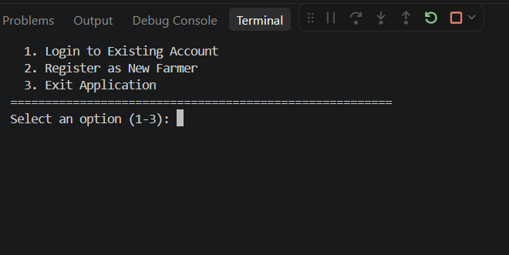
Figure 5.1 User Login Portal
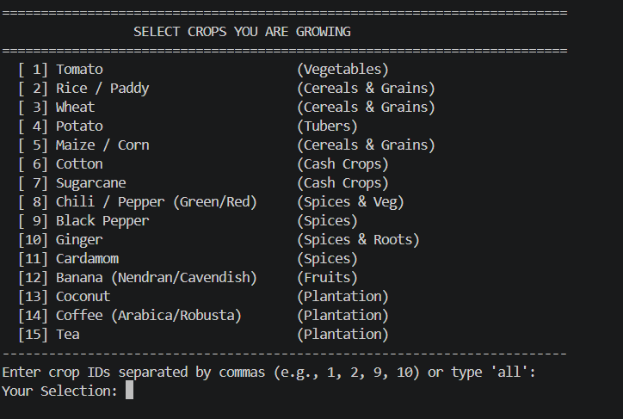
Figure 5.2 Farmer Crop Selection Menu

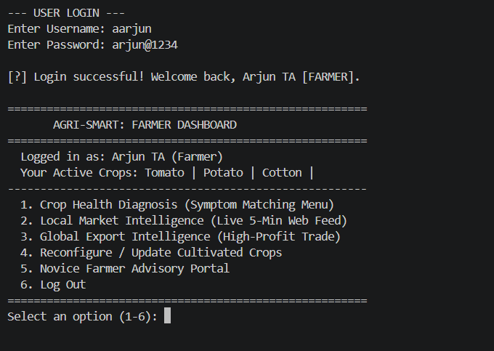
Figure 5.3 Farmer Dashboard
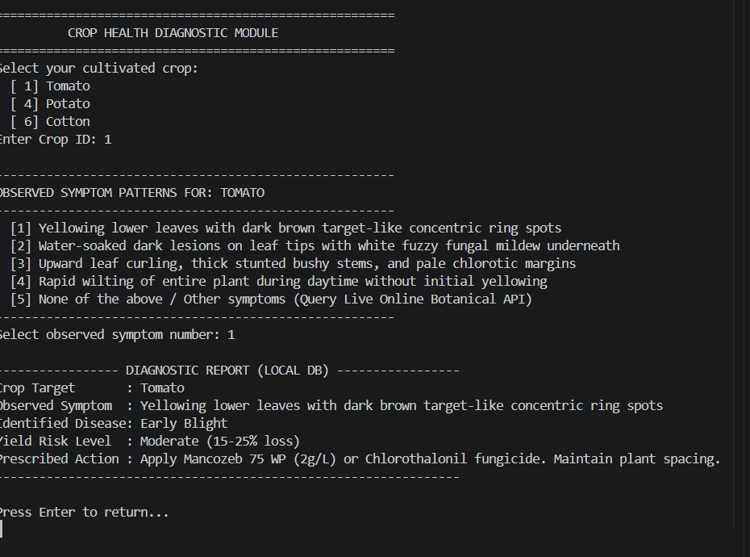
Figure 5.4 Crop Health Diagnostic Module

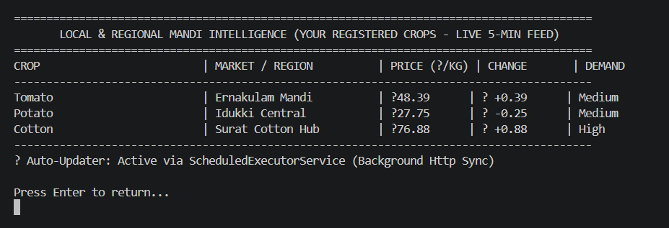
Figure 5.5 local Market Prices with online auto updater

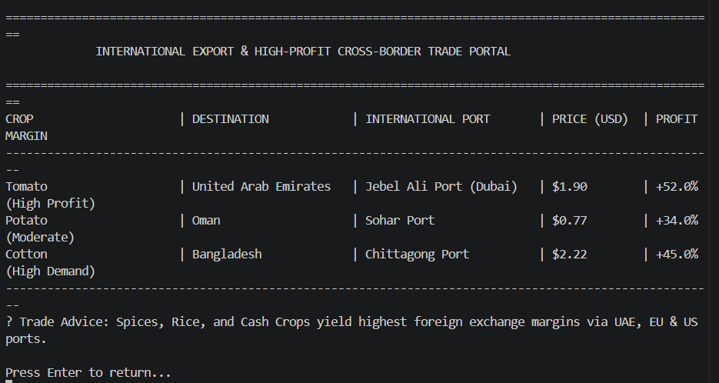
Figure 5.6 International Export Prices with Online Updater

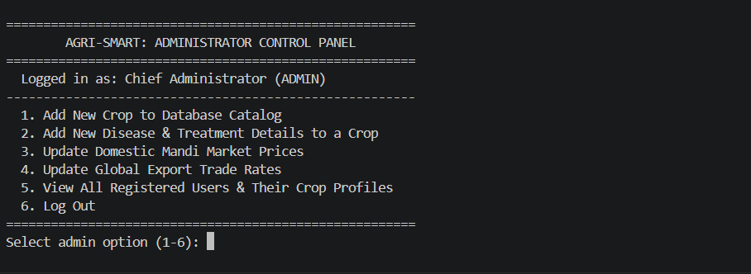
Figure 5.7 Admin Control Pannel
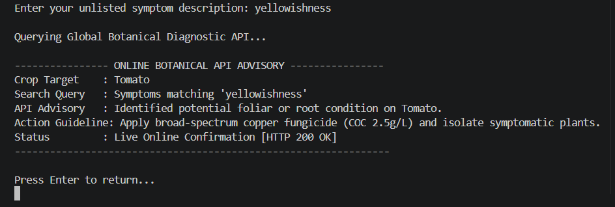
Figure 5.8 Online Api Advisory

CHAPTER - 5

CONCLUSION AND FUTURE WORK
5.1 CONCLUSION
The Agri-Smart System successfully demonstrates the design and deployment of an integrated, terminal-based agricultural decision-support platform built strictly using pure Java and Object-Oriented Programming (OOP) paradigms. By utilizing core in-memory collections (Map, List, Set) paired with standard Java File I/O stream serialization (BufferedReader, BufferedWriter), the system achieves zero-overhead runtime responsiveness and maintains persistent cross-session user records via agrismart_users.txt without incurring any external SQL database server dependencies.
The platform effectively bridges the gap between field-level crop pathology containment and commercial agricultural marketing. Its deterministic, menu-driven Crop Health Diagnostic Module provides rapid pathogen identification, quantified yield loss risk assessments, and targeted remediation guidelines across 15+ staple, cash, and plantation crops, backed by an automated HTTP botanical API fallback for unindexed anomalies. Furthermore, through non-blocking background concurrency powered by ScheduledExecutorService, Agri-Smart auto-synchronizes domestic mandi spot rates while evaluating cross-border export profitability across key global commercial distribution hubs. By centralizing disease diagnosis and market intelligence into a lightweight, portable console application, the project eliminates rural information asymmetry, mitigates middleman exploitation, and safeguards farm productivity.
5.2 FUTURE WORK
- Graphical User Interface (GUI) Evolution: Transition from the terminal CLI to an interactive desktop GUI using JavaFX or a responsive cross-platform web interface to enhance accessibility for diverse user groups.
- Computer Vision Leaf Pathology Detection: Integrate on-device deep learning or convolutional neural network (CNN) image processing models to detect crop diseases automatically through uploaded leaf photographs.
- Live e-NAM API Connectivity: Establish authenticated network integration directly with the official Electronic National Agriculture Market (e-NAM) endpoints to fetch real-time state mandi prices and arrival volumes across India.
- Microclimate & Predictive Weather Alerting: Connect localized meteorological forecasting APIs to compute ambient humidity and precipitation trends, providing early warnings before seasonal fungal sporulation or pest outbreaks occur.
- Automated Mobile Messaging Gateways: Implement programmatic SMS or WhatsApp notifications to dispatch critical harvesting alerts, emergency disease advisories, and sudden commodity price spike notices directly to cultivators' mobile phones.

REFERENCES
[1] Oracle Corporation, "Java Platform, Standard Edition Documentation - java.net.http," Oracle Help Center. https://docs.oracle.com/en/java/javase/docs/api/java.net.http/java/net/http/HttpClient.html[cite: 1]
[2] Oracle Corporation, "Interface ScheduledExecutorService - Java Platform SE 17," Oracle Help Center. https://docs.oracle.com/en/java/javase/17/docs/api/java.base/java/util/concurrent/ScheduledExecutorService.html[cite: 1]
[3] GeeksforGeeks, "Switch Statement in Java," GeeksforGeeks Portal. https://www.geeksforgeeks.org/java/switch-statement-in-java/[cite: 1]
[4] W3Schools, "Java Tutorial: OOP Concepts, File I/O, and Streams," W3Schools Online Web Tutorials. https://www.w3schools.com/java/[cite: 1, 2]
[5] Javatpoint, "Java ScheduledExecutorService Example & Multithreading," Javatpoint Java Concurrency Guide. https://www.javatpoint.com/java-scheduledexecutorservice[cite: 1]
[6] Wikimedia Foundation, "MediaWiki REST API: Page Summary Endpoint Documentation," Wikimedia REST API Guide. https://en.wikipedia.org/api/rest_v1/
[7] Open Exchange Rates, "Free and Open Currency Exchange Rates API," Open Exchange Service Documentation. https://open.er-api.com/v6/latest/USD

